|  |  |
| --- | --- |
|  | **[Year]** |
|  | [Type the company name]  Ahmad Algohary |

|  |
| --- |
| **[Type the document title]** |
| [Type the abstract of the document here. The abstract is typically a short summary of the contents of the document. Type the abstract of the document here. The abstract is typically a short summary of the contents of the document.] |

Table of Contents

Introduction 2

Getting Started 2

Installation 2

Application Main Window 7

Loading (Volume Images, Prostate Masks & Probabilities Files) 8

Saving () 10

Advanced Practices 11

# Introduction

CaPView is a simple program which loads and displays MRI volume images. It also visualizes the cancer classification data generated at CCIPD. It gives the radiologist a flexible, yet simple, means of deciding biopsy regions. Currently, It is only intended for research purposes.

# Getting Started

## Installation

1. Double-click the installer executable file.

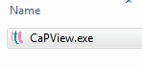

1. A welcome window will pop-up, click the “Next >” button to continue.

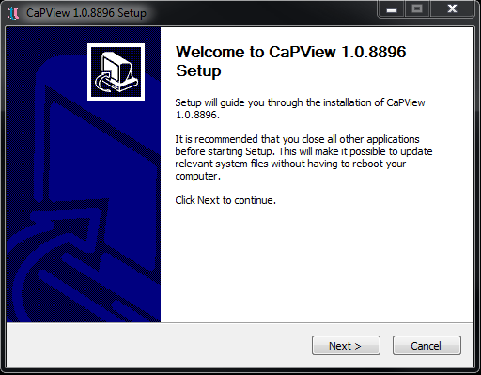

1. Read the end user license agreement, check the box and click the “Next >” button to continue.

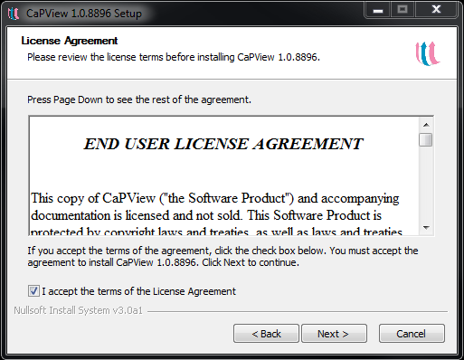

1. The Start menu folder Window will now show up, you may choose the name of the program group folder in the start menu or leave the default name as it is (CaPView). Click the “Install” button to continue.

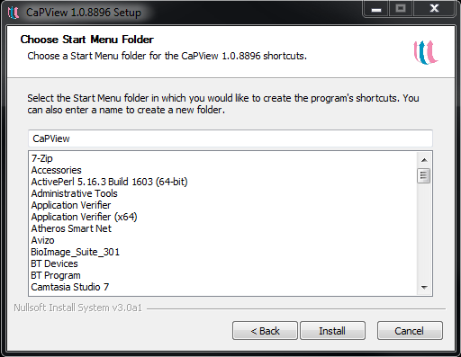

1. Select the installation folder where the program executable and associated files will be installed. If you leave it without change, it will be installed in the “Program Files” directory. Click the “Next>” button to continue.

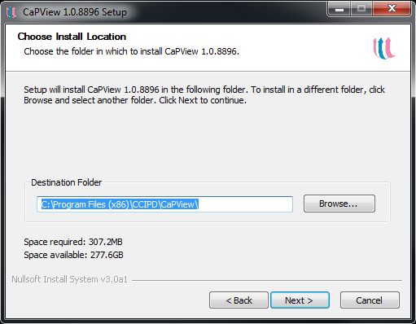

1. The installation will start, when the progress bar comes to the end, click the “Next >” button to finish the installation.

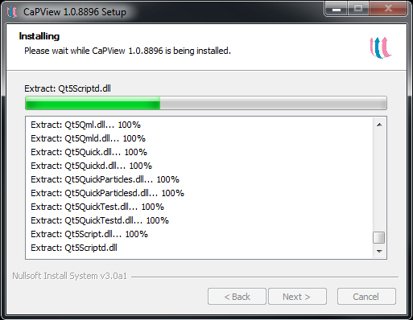

1. After setup is complete, click the “Finish” button to run CapView for the first time.

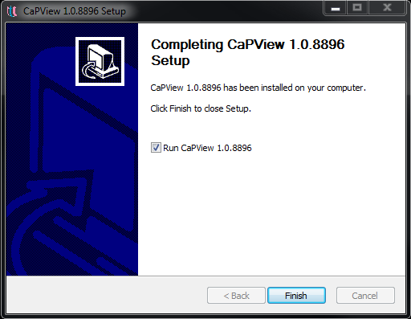

## Application Main Window

One of the most important features of CaPView is that it simplifies the MRI visualization process via laying out all the required options on one user-friendly user interface.

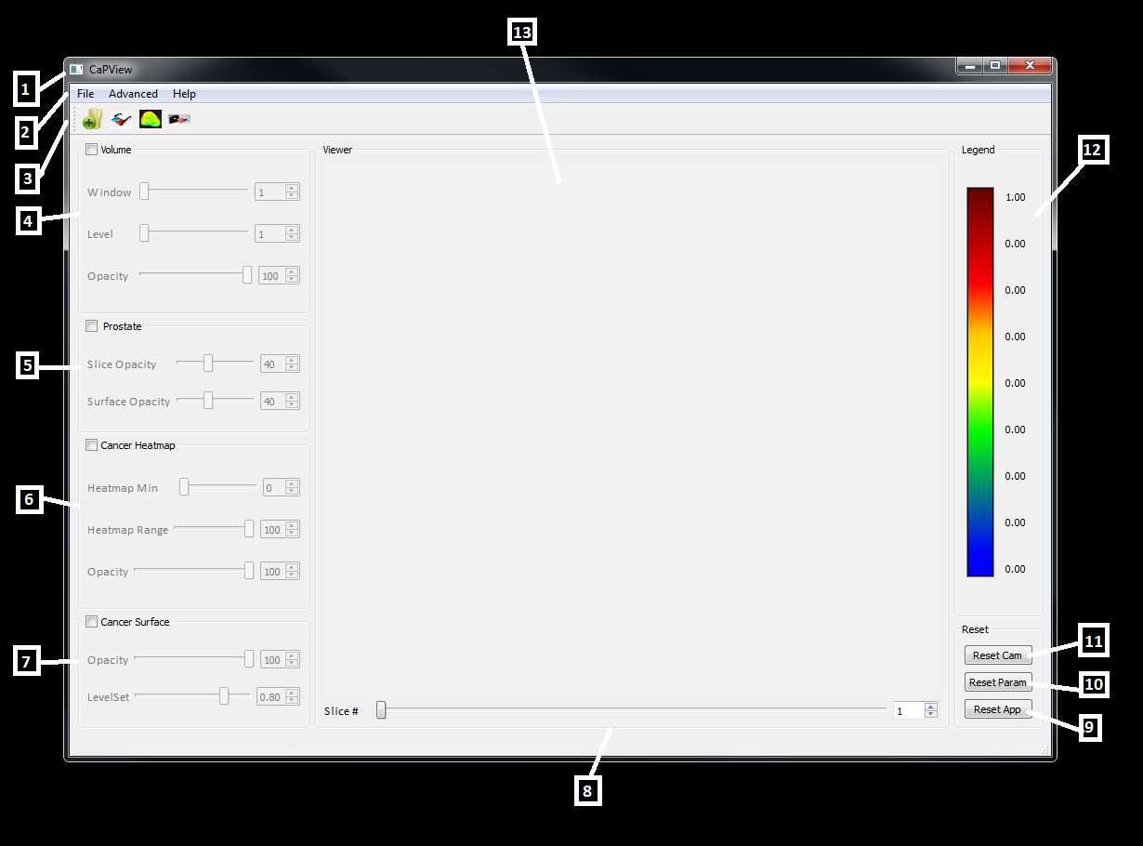

1. The Main Application Window: It has all the program functionalities.
2. The Menu Bar: This has three menus:
3. File: for loading, saving medical image files and quitting the program
4. Advanced: for changing the surface colors of the loaded objects (Prostate, CG, PZ & cancer)
5. Help: Contains the help material for the program.
6. Tool Bar: This contains shortcuts to the most commonly used actions (Load Volume Image, Load Mask, Load Cancer Probabilities Image).
7. Volume control group box: contains three sliders and editable spin boxes:
8. Window Width Slider: modifies the window width of the currently displayed volume.
9. Window Level slider: modifies the window level of the currently displayed volume.
10. Opacity Slider: modifies the opacity/transparency of the currently displayed volume.

The Volume control group box has a check box which shows/hides the volume while visualizing the volume data. This checkbox, with the sliders, are enabled only when the volume image is already loaded.

1. Prostate control group box: This controls the visualization of the loaded prostate mask.

It contains two sliders and editable spin boxes:

1. Slice Opacity: modifies the opacity/transparency of the currently displayed prostate 2D slices.
2. Surface Opacity: modifies the opacity/transparency of the currently displayed prostate 3D surface.

The Prostate control group box has a check box which shows/hides the prostate objects (2D Slices and 3D surfaces) while visualizing the volume data. This checkbox, with the sliders, are enabled only when the prostate mask image is already loaded.

1. Cancer Heatmap control group box: This controls the visualization of the loaded cancer probabilities image. The dark red color represents the highest cancer probability while the blue is for the lowest. Displayed ranges can be modified via the range control sliders.

It contains three sliders and editable spin boxes:

1. Heatmap Min slider: which controls the minimum cancer probability value to be displayed. All values below this value will not be displayed.
2. Heatmap Max slider: which controls the maximum cancer probability value to be displayed. All values above this one will be labeled as cancerous and will be given the dark red color.
3. Opacity: modifies the opacity/transparency of the currently displayed heatmap.

The heatmap control group box has a check box which shows/hides the cancer probabilities image. This checkbox, with the sliders, are enabled only when the probabilities image is already loaded.

1. Cancer Surface control group box: This controls the visualization of the cancer surface calculated from the loaded cancer probabilities image. This depends on the levelset value selected. All the values above this value will be considered as cancerous and will be added to the constructed surface.

It contains two sliders and editable spin boxes:

1. Opacity: modifies the opacity/transparency of the currently displayed surface.
2. Levelset Value: which controls threshold value of cancer.

The Cancer Surface control group box has a check box which shows/hides the constructed cancerous regions. This checkbox, with the sliders, are enabled only when the probabilities image is already loaded.

1. Slice Number Slider: this enables the user to traverse volume slices.
2. “Reset App” button: resets the whole program, clears the viewer and resume its starting state.
3. “Reset Params” button: resets all the parameters to their default values, all sliders are set to their mid-value accordingly.
4. “Reset Cam” button: resets the viewer. This action brings all the hidden, or not fully displayed, parts of the volume objects to the viewable area of the central viewer.
5. The legend with the range values: this is the color legend of the cancer probabilities. It can be modified by moving the heatmap min and max sliders. Colors are not changed but the numbers over the legend bar are fully controllable.
6. The central viewer of the program where volume slices and cancer probabilities surfaces are displayed.

# Operation

Each time you launch CaPView, the application by default shows the main startup dialog window that allows you to load, visualize and manipulate data files:

## Loading (Volume Images, Prostate Masks & Probabilities Files)

To load a volume: Select in the File menu:

File -> Load -> Volume Image

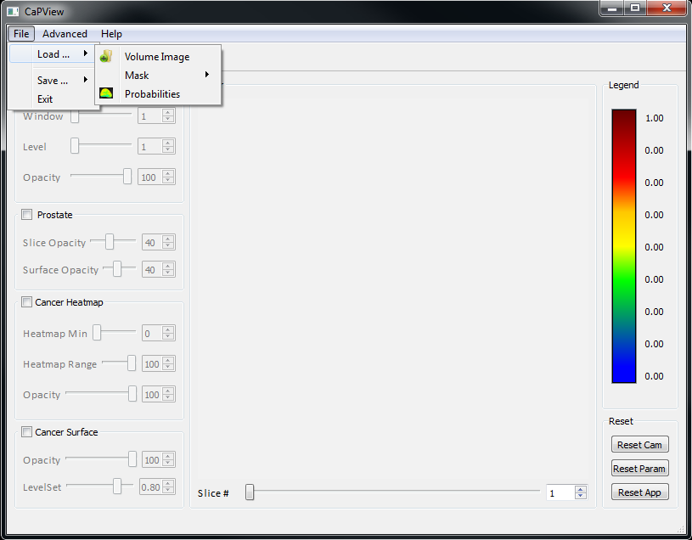

You can also press the first shortcut icon in the toolbar to load a volume image.

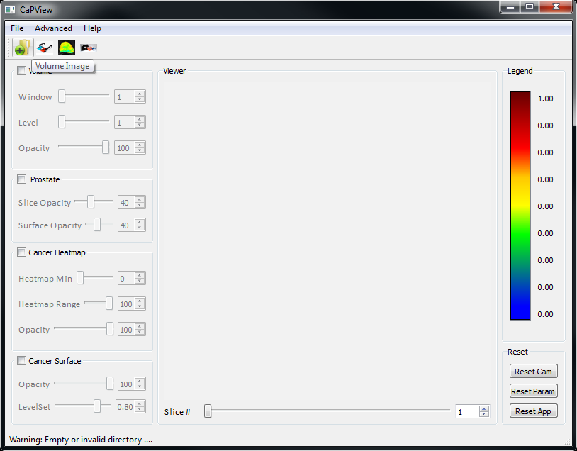

In the same manner, you can load the prostate mask image file and the corresponding cancer probabilities image.

## Saving

You can save a snapshot of the 3D viewer on the user interface window with all the included objects (volume slices, prostate surface, …) with you own settings as a regular image file by selecting “Save Viewer Image As …” in

File -> Save -> Save Viewer Image As

You may also save a snapshot of the whole user interface by selecting “Save App Image As …” in

File -> Save -> Save App Image As

This can help you send your optimally selected settings to another user to be used later. You do not need to save settings if you are the only user of the program as all the user options and program parameter and geometry settings will all be saved and loaded automatically at the exit and startup of the program.

